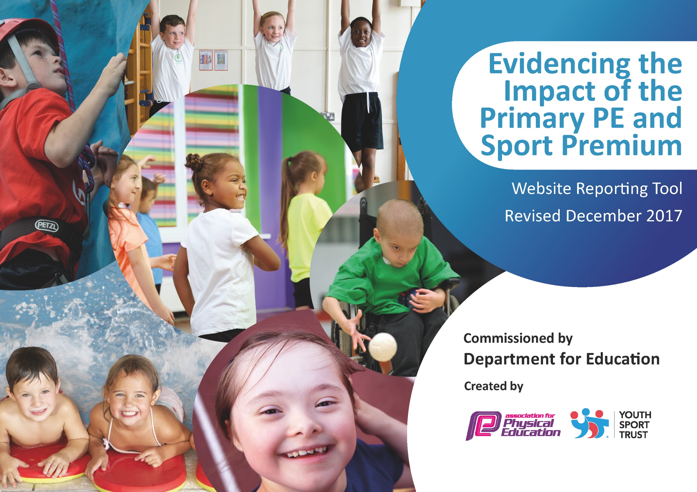

Primary PE and Sport Premium 2017-2018
At Mountbatten Primary we believe that PE & Sport plays an important role in changing young people’s lives for the better.
We are committed to using this resource in developing high quality PE lessons, alongside greater opportunities for sporting competitions and clubs for all our young people. At Mountbatten we will use the funding to make additional and sustainable improvements to the quality of Physical Education and School Sport we offer. We will use the premium to: -
• develop and add to the PE and sport activities that Mountbatten already offers
• build capacity and capability within the school to ensure that improvements made now will benefit pupils joining the school in future years.
There are five key indicators that schools should expect to see improvement across: -
• the engagement of all pupils in regular physical activity - the Chief Medical Officer guidelines recommend that all children and young people aged 5 to 18 engage in at least; 60 minutes of physical activity a day, of which 30 minutes should be in school
• the profile of Physical Education and School Sport is raised across the school as a tool for whole-school improvement
• increased confidence, knowledge and skills of all staff in teaching Physical Education and School Sport
• broader experience of a range of sports and activities offered to all pupils
• increased participation in competitive sport.
Sport Premium Grant
Funding for schools will be calculated by the number of primary aged pupils (between the ages of 5 and 11). All schools with 17 or more primary aged pupils will receive a lump sum of £16000 plus a premium of £10 per pupil.
Total amount of grant received for 2017/2018 £18170
What does the Sport Premium mean for our School?
‘Schools must spend the additional funding on improving their provision of PE and sport, but they will have the freedom to choose how they do this’ (DFE June 2013). At Mountbatten Primary we have decided to spend the Sport Premium Grant on the following:

Academic Year: 2017/18 | Total fund allocated: £18170 | Date Updated:26/3/18
Key indicator 1: The engagement of all pupils in regular physical activity – Chief Medical Officer guidelines recommend that primary school children undertake at least 30 minutes of physical activity a day in school |  |  |  | Percentage of total allocation:
 |  |  |  | 6.6%
School focus with clarity on intended impact on pupils: | Actions to achieve: | Funding allocated: | Evidence and impact: | Sustainability and suggested next steps:
- Playtimes and lunchtimes to be active ensuring all children achieve at least 30 minutes of physical activity a day in school.  - Importance of Physical Activity promoted in breakfast club. | - Introduction of School Sport Ambassadors to arrange activities for playtimes and lunchtimes.  - Lunchtime staff to ensure a range of physical activities offered at lunchtime.  - All staff to ensure a range of physical activities offered at playtimes.  - New equipment purchased to enable activities to go ahead – replaced when damaged.  - Hull FC to deliver a 40 minute multi skills session during breakfast club 2 days per week. | HAS FUNDING  - £1200  HULL FC GOLD PACKAGE | - 100% of children are physically active at playtimes and lunchtimes daily.  - Leadership skills developed by School Sport Ambassadors – promoting Healthy Active Lifestyles to peers. | - Regular CPD updates for all staff  - Any new lunchtime staff to buddy up to learn how to deliver physical activities.  - Regular checks on equipment.  - Promote Sport Ambassadors to encourage more children to take on the role next year.
Key indicator 2: The profile of PE and sport being raised across the school as a tool for whole school improvement |  |  |  | Percentage of total allocation:
 |  |  |  | 23.56%
School focus with clarity on intended impact on pupils: | Actions to achieve: | Funding allocated: | Evidence and impact: | Sustainability and suggested next steps:
- Children to be educated on the importance of Healthy Active Lifestyles including diet.  - Raise the profile of all PE and sport within the school day and its impact on the whole child to improve children’s mental and physical health and attainment.  - Change 4 Life club to be continued to run to continue the improved engagement in lessons of targeted children.  - Regular visits from Hull FC to promote the importance of PE and Sport to children  - Improve attendance through links with Hull FC with Gold Package reward at end of year eg shirt/season pass | - Healthy Cooking Club to be delivered where healthy eating is promoted and children taught healthy recipes.  - PE Subject Leader to deliver CPD to all staff regarding the impact physical activity and healthy lifestyles have on children’s attainment levels and the impact it has on their physical and mental health.  - Promote Active Literacy and Active Maths across the school.  - Promote 2 minute activities to engage children in lessons  - PE Subject Leader to continue to run C4L club targeting children who do not take part in any other sporting or after school activity and those that are passive learners within the classroom.  - Gold Membership with Hull FC | - £280  - £4000 | - 20 children attend weekly cooking club- waiting list to join  - All staff aware of the importance of PE and sport within school and how this can be addressed in all lessons throughout the school day.  - Children accessing Active lessons throughout the day not just in PE lessons.  - Behaviour and attainment within lessons improved.  - 12 children targeted from KS2, all have now represented the school in at least one sporting event, noticeable difference in children’s confidence when at the club. Improved engagement from 100% of pupils within curriculum time.  - 100% of children have received regular visits from Hull FC first team players which has enabled them to have discussions with them over lunch regarding the importance of healthy diet. Questions and answer sessions in assemblies on how to stay fit and the importance of exercise and how this can be achieved in a school day. 100% of children know the values that underpin sport and how this relates to everyday life, Respect, Determination, Self-Belief, Passion, Teamwork and Honesty these values are promoted across the school within all lessons.  - Whole school attendance improved. | - All staff to observe lessons involving activity breaks.  - All staff to have the opportunity to observe Active Maths lessons.  - PE Subject Leader to monitor amount of active lesson delivered over the course of a day.  - C4L to continue with CPD for other members of staff to enable shared delivery of club  - CPD for lunchtime staff to enable a C4L club to be delivered on a lunchtime targeting children with behaviour issues on lunchtimes.  - One child selected termly from EYFS, KS1 and KS2 to receive an award for each value Respect, Determination, Self-Belief, Passion, Teamwork and Honesty

Key indicator 3: Increased confidence, knowledge and skills of all staff in teaching PE and sport |  |  |  |  | Percentage of total allocation:
 |  |  |  |  | 3.8%
School focus with clarity on intended  impact on pupils: | Actions to achieve: | Funding  allocated: |  | Evidence and impact: | Sustainability and suggested  next steps:
- Staff to deliver a broad and balanced PE curriculum with quality engaging lessons for children with clear skills progression across the school.  - Accredited RFL CPD training | - Renewal of Ipep interactive planner, tracker and assessment tool.  - PE Subject Leader to observe lessons.  - PE Subject Leader to carry out pupil interviews and share outcomes with staff.  - Deliver CPD on using Ipep for new staff  - PE Subject Leader to attend CPD to increase knowledge and skills.  - One Day Dance CPD for staff  - Hull FC Gold Package School Sports Partnership | - £490  - £200  - HULL FC GOLD PACKAGE |  | - Clear progression of skills in PE lessons from EYFS to Year 6 KS2  - Quality of teaching improved, raised attainment for pupils  - SEND provision improved for children within lessons now 100% of SEND children fully accessing PE lessons.  - All children engaged in PE lessons  - Staff knowledge and confidence improved in delivering Dance.  - Staff able to deliver high quality Invasion Game lessons and deliver high quality after school Rugby Club | - Review the impact of Ipep yearly  - PE Subject Leader to identify any staff who require further support to develop delivery of high quality PE lessons and increase knowledge  - Good practice shared through filming of PE lessons and shared at staff meeting with other staff.  - CPD to be redelivered to all staff male and female.
Key indicator 4: Broader experience of a range of sports and activities offered to all pupils |  |  |  |  | Percentage of total allocation:
 |  |  |  |  | 53.6%
School focus with clarity on intended  impact on pupils: | Actions to achieve: | Funding  allocated: | Evidence and impact: |  | Sustainability and suggested  next steps:
- Opportunity for all children to access new sports to further their experiences | - Karen Briggs Judo Club delivering 50 minute sessions to individual classes on a 6 week Rota basis throughout the year to EYFS, KS1 and KS2  - Hull Scorpions Baseball & Softball Club delivering 60 minute sessions to individual classes on a 7 week Rota basis to KS2 children during Summer Term.  - JB Sports & Dance to deliver after school activities and dance CPD for staff  - Purchase inclusive PE equipment eg Boccia, New Age Kurling | - £2880  - £560  - £5460  - £840 | - Only 2 children (0.9%) had experienced the sport of Judo before this, by the end of the year 100% will have experienced.  - 1 child so far has become a member of the club and representing them at competitions.  - Positive impact on behavior due to discipline expected within Judo.  - Only 10//144 (6.9%) children had experienced the sport of Softball before this, by the end of the year 100% of KS2 children will have experienced.  - Y3/4 Tournament entered all children to take part  - Y5/6 Tournament entered all children to take part.  - Staff upskilled to deliver softball sessions next year.  - Children have had the opportunity belong to Gymnastics club 19% – gaining recognised gymnastic awards, Cheerleading Club,14% Multi skills 17% Performing Arts 13%  - Quality coaching received in afterschool clubs which has developed skills in curriculum PE lessons  - Children to access new games and engagement with other children of a lesser ability. |  | - Feedback from staff 100% positive, to be continued next year to encourage more children to access the club and continue widening opportunities for children.  - CPD to further staff development with the possibility of a member of staff being able to deliver basic Judo skills.  - Staff observe sessions and take an active part enabling them to deliver Softball sessions next year.  - Staff to deliver a range of after school clubs next year.  - Gymnastics club to be continued next year by JB Sports.
Key indicator 5: Increased participation in competitive sport |  |  |  |  | Percentage of total allocation:
 |  |  |  |  | 12.66%
School focus with clarity on intended  impact on pupils: | Actions to achieve: | Funding  allocated: |  | Evidence and impact: | Sustainability and suggested  next steps:
- All children regardless of ability to have access to competitive sport.  - Increase the number of children participating in competitive sport and the number of events entered. | - Sign up for membership of Hull Active Schools  - Enter inclusive events held by Hull Active Schools.  - Enter compettions held by Hull Active Schools  - Enter Competitons held by outside agencies.  - Transport provided by school | - £1500  - £800 |  | - 82% of pupils in KS2 with SEND have participated in competitive sport.  - 75% of KS2 pupils represented the school in competitive sport.  - 9% of KS1 pupils represented the school in competitive sport  - Taken part in 24 different competitive sporting events, children learning new sports and improvement in skills. | - Continue membership of Hull Active Schools  - Increase number of events attended for KS1 children

Meeting national curriculum requirements for swimming and water safety | Please complete all of the below*:
What percentage of your current Year 6 cohort swim competently, confidently and proficiently over a distance of at least 25 metres? | 15/32 46.9%
What percentage of your current Year 6 cohort use a range of strokes effectively [for example, front crawl, backstroke and breaststroke]? | 10/32 31.3%
What percentage of your current Year 6 cohort perform safe self-rescue in different water-based situations? | 15/32 46.9%
Schools can choose to use the Primary PE and Sport Premium to provide additional provision for swimming but this must be for activity over and above the national curriculum requirements. Have you used it in this way? | No, but are using it next year based on this year’s findings.

